**PROXIMITY SENSOR:**

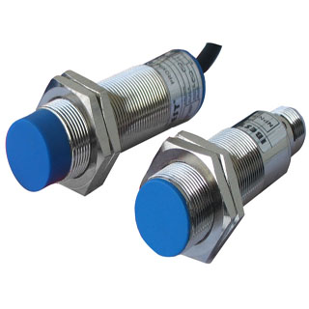

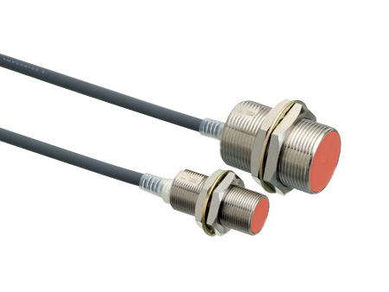

A proximity sensor, in particular a proximity switch is described. A component that pertains to a system variable and is independent from the material of a trigger or target is elected and transformed into a non-periodic signal that depends upon the distance of the trigger. The trigger of a proximity sensor can thus be exchanged randomly without requiring subsequent adjustments. The impedance of an oscillation circuit which pertains to the proximity sensor, the impedance of an oscillation circuit coil, the amplitude of the oscillation circuit signal or a voltage divider ratio between the oscillation circuit and the additional resistance can be used s system variables for instance.

A proximity sensor for determining an approaching direction of an object is provided. Relative detection sensitivity is established in a first detection unit and a second detection unit such that a detection level of the first detection unit is greater than a detection level of the second detection unit when the object approaches from a first electrode in a direction of arranging the first electrode and a second electrode, and that the detection level of the second detection unit is greater than the first detection unit when the object approaches from a direction perpendicular to the direction of arranging the first electrode and the second electrode. A proximity position determining section is adapted to determine the approaching direction of the object based on the detection level of the first detection unit and the detection level of the second detection unit.

As noted above, it is desired to provide a proximity sensor capable of determining an approaching direction of an object.A characteristic feature of the present invention lies in a proximity sensor for detecting approach of an object based on capacitance, including:an electrode section including a first electrode and a second electrode arranged adjacent to each other;

a detecting section including a first detection unit for detecting approach of the object based on variations in capacitance of the first electrode, and a second detection unit for detecting approach of the object based on variations in capacitance of the second electrode, wherein relative detection sensitivity is established in the first detection unit and the second detection unit such that a detection level of the first detection unit is greater than a detection level of the second detection unit when the object approaches from the first electrode in a direction of arranging the first electrode and the second electrode, and that the detection level of the second detection unit is greater than the first detection unit when the object approaches from a direction perpendicular to the direction of arranging the first electrode and the second electrode; and

a proximity position determining section for determining the approaching direction of the object based on the detection level of the first detection unit and the detection level of the second detection unit.

With this arrangement, the proximity position determining section is provided for establishing the relative detection sensitivity for the first unit having the first electrode and the second unit having the second electrode to determine the position of the object based on the detection levels from the first unit and second unit. This makes it possible to determine the approaching direction of the object based on the determination results received from the proximity position determining section without providing the shield and the like. As a result, the proximity sensor capable of determining the approaching direction of the object can be easily achieved.

In the proximity sensor of the present invention, the relative detection sensitivity may be established by determining detection performance of the first detection unit and the second detection unit or by determining configurations of the first electrode and the second electrode. With such an arrangement, the relative sensitivity is achieved in response to the mode of use or the condition in use by establishing the detection sensitivity by the first detection unit and the second detection unit, or by determining the configurations of the first electrode and the second electrode, or by the combination thereof.

The proximity sensor of the present invention may further comprise a belt-like ground electrode provided in the electrode section and having a longitudinal section extending along a peripheral direction of a tubular substrate, wherein the belt-like first electrode and second electrode are arranged on the substrate along the peripheral direction with the ground electrode between them and parallel with the ground electrode.

With this arrangement, it is possible to form the first electrode, the ground electrode and the second electrode on the tubular substrate in the mentioned order. For example, it makes it possible not only to facilitate fabrication of the sensor compared with the arrangement in which an electrode and an insulating material are layered but also to align the arranging direction of the first electrode and the second electrode with an axial direction of the tubular substrate. As a result, it is possible to distinguish between the approach of the object from a direction along the axial direction and the approach of the object from a direction perpendicular to the axial direction.

Further, a characteristic feature of a rotational operation detecting device of the present invention having a rotation detecting section for detecting a rotational operation of a rotationally-operable knob about an axis, the rotational operation detecting device comprising:

a first electrode arranged inside the knob at a distal end of the axis in a direction along the axis;a second electrode arranged inside the knob at a proximal end of the axis in a direction along the axis.A detection section including a first detection unit for detecting approach of an object based on variations in capacitance of the first electrode and a second detection unit for detecting approach of the object based on variations in capacitance of the second electrode, wherein relative detection sensitivity is established such that a detection level of the first detection unit is greater than a detection level of the second detection unit when the object approaches from the first electrode in a direction along the axis and that the detection level of the second detection unit is greater than the first detection unit when the object approaches from a direction perpendicular to the direction along the axis;

a proximity position determining section for determining the approaching direction of the object based on the detection level of the first detection unit and the detection level of the second detection unit; and

an output control section for allowing output of signals from the rotation detection section only when a rotational operation is detected in the rotation detection section when the proximity position determining section detects approach of the object from the direction perpendicular to the axis.

With this arrangement, the detection level of the first detection unit becomes higher than the detection level of the second detection unit when the object approaches from the distal end along the axis of the knob. On the other hand, the detection level of the second detection unit becomes higher than the detection level of the first detection unit when the object approaches from the direction perpendicular to the axis of the knob. The proximity position determining section is adapted to recognize the difference in detection level, thereby distinguishing between the state where the user pinches or grips the knob to rotate the knob and the sate the sleeve of the user\'s clothing or part of the user\'s body contacts an end portion of the knob to rotate the knob. The output control section allows output of signals from the rotation detection section only when it can be determined that the user intentionally has operated the knob based on the determination results from the proximity position determining section. As a result, the rotational operation detecting device is capable of disregarding operations executed unintentionally by the user and extracting only the amount of rotation resulting from proper operations.

Still further, the rotational operation detecting device of the present invention may comprise a sheet-like substrate that is flexibly deformable,wherein a belt-like ground electrode is formed on the substrate in a predetermined direction, the belt-like first electrode and second electrode being formed on the substrate with the ground electrode between them and parallel with the ground electrode, and wherein the substrate has a tubular shape to be fitted into the interior of the knob, on which the belt-like ground electrode as well as the belt-like first electrode and second electrode are arranged in a peripheral direction centering the axis.

With such an arrangement, since the sheet-like substrate with the electrodes being formed thereon has a tubular shape to be fitted into the interior of the knob, it is not required to form the electrode directly in the interior of the knob. As a result, the capacitance-type sensor may be easily fabricated.